Functional Test Report for eSignet-Go 2.0.0 GA
22 Sep 2026


Document History
It outlines the strategy used to ensure a comprehensive evaluation.

Version | Author | Date | Review | Affected Sections
v1.0 | Santosh | 22/09/2026 | Ragini Krishnamurthy

Contents

1. Introduction 4
1.1 Overview and Scope 4
2. Test Approach 4
3. Test Organization 5
4. Test Planning 5
4.1 Sanity Scenarios Verified 5
4.2 Test Environment 6
5. Docker versions in 131ga environment: 6
6. Test Execution Report 8
6.1 Test case execution summary 8
6.2 Automation Results 9
6.3 Detailed Test metrics 10
6.4 Browser compatibility evaluations 10
7. Feature Health 11
8. Sonar Report 12
9. Conclusion 12
10. Appendix 13

Introduction
The eSignet 2.0.0 testing scope includes the validation of authentication, authorization, consent management, token generation, OpenID Connect (OIDC) flows, client management and partner (PMS) integration across supported authentication methods and identity systems (Mock ID, MOSIP ID and Sunbird). eSignet is a modular and standards-based digital identity authentication solution that supports secure and configurable login journeys using OTP, password, biometrics, KBI and trusted identity providers.

1.1 Overview and Scope
The scope of testing defines the boundaries, functionalities, and features that will be tested for the eSignet platform. This ensures comprehensive validation of critical authentication, authorization, consent, and identity verification workflows while clearly identifying what is included and excluded from testing.
Functional Features: Login with eSignet – end-to-end OIDC flow on the Go (Thunder) build (authorize, flow/execute, callback, token, userinfo), Auth factors rendered as per the configured ACR values, Login with OTP, Password, Biometrics and KBI (Knowledge-Based Identification), Multiple login ID types (UIN/VID/handle) with input validations (regex, length, prefix and postfix), Mock ID, MOSIP ID and Sunbird Plugin Integration, Client (RP) name in multiple languages, Regex pattern support for redirect_uri, UserInfo and ID token as JWE, FAPI 2.0 Compliance – Issuer Identifier, PAR (Pushed Authorization Request) and DPoP (Demonstration of Proof-of-Possession), OIDC Authorization Flow with PKCE, Branding (client logo, client name, theme) and UI alignment, Consent service and Consent page (prompt=consent), Captcha in authenticate requests, Redis Cache, Client Management endpoints and PMS Integration (additionalConfig), Keystore support (PKCS12/SoftHSM), Claims Management, Audit Logging and Deployment Testing for eSignet Go.
Cross-Platform Support:
- Multilingual: eSignet with 6 languages (English/Khmer/Hindi/Kannada/Arabic/Tamil)
- Multi-Browser: Edge, Firefox, Chrome
- Devices: Windows, Mac, Tablet, Mobile.
- Testing Types: Sanity, Regression Testing and Integration Testing
- Cross-browser and cross-device compatibility testing.

Test Approach
The scope of testing is to verify fitment to the specification from the perspective of
☒ Functionality
☐ Combination
☒ UI Automation
☒ API Automation
☐ Library verification

Test Organization
This part lists the team members involved in the testing process and their responsibilities. It clarifies who is accountable for which roles.
Table 1: Test Organization
Name | Functional Role | Responsibilities
Ragini Krishna | Manager | Defining test strategy, managing QA activities, and ensuring overall product quality.
Santosh | Test engineer | Designing and executing test cases, performing functional and regression testing, validating eSignet authentication workflows, verifying login and identity verification functionalities, logging and tracking defects, validating fixes, and ensuring overall application quality, security, and compliance standards.

Test Planning
This Test Plan outlines the testing approach, scope, resources, and schedule for the eSignet 2.0.0 platform. The objective is to ensure that all functional, integration, security, and non-functional requirements are validated with high quality before release.
This Test Plan outlines the testing approach, scope, resources, and schedule for the eSignet 2.0.0 platform. The objective is to ensure that all functional, integration, security, and non-functional requirements are validated with high quality before release.
- Validate end-to-end functionality of eSignet authentication and authorization workflows.
- Ensure system stability across supported browsers, operating systems, plugins, and environments.
- Verify integrations with dependent systems, identity providers, and authentication services.
- Validate OIDC, DPoP, PAR, and FAPI 2.0 compliance workflows.
- Identify and mitigate risks early through functional, regression, integration, and deployment testing.
- Ensure compatibility of Docker Compose setup across Windows, macOS, and Linux operating systems.
- Verify secure login mechanisms including OTP, Password, Biometrics, and KBI authentication methods.

4.1 Sanity Scenarios Verified
Sanity testing will be performed to ensure basic application stability before detailed test execution. The following high-level sanity scenarios will be verified:
- Application accessibility and successful login across supported authentication methods and environments.
- Login validation using OTP (Phone Number, UIN/VID, and Email).
- Login validation using Password authentication.
- Basic biometric authentication validation using Mock ID and MOSIP ID.
- KBI (Knowledge-Based Identification) login validation.
Only upon successful completion of sanity testing will the build be accepted for full regression and integration testing.

4.2 Test Environment
- https://esignet-go.esqa.mosip.net – Mock ID environment
- https://esignet-go-mosipid1.esqa.mosip.net – MOSIP ID environment
- https://esignet-go-sunbird.esqa.mosip.net – Sunbird environment

Docker versions in 131ga environment:
Table 2: Test Environment images
Tested with Components on esqa env
docker.io/library/busybox:1.36
docker.io/istio/operator:1.22.0
docker.io/istio/pilot:1.22.0
docker.io/istio/proxyv2:1.22.0
docker.io/kennethreitz/httpbin:latest
docker.io/library/mongo:6.0.13
docker.io/minio/mc:RELEASE.2025-05-21T01-59-54Z
docker.io/minio/mc:latest
docker.io/mosipdev/esignet-with-plugins:release-1.8.x
docker.io/mosipdev/oidc-ui:release-1.8.x
docker.io/mosipdev/partner-onboarder:develop
docker.io/mosipdev/postgres-init:develop
docker.io/mosipid/captcha-validation-service:0.1.0-beta.1
docker.io/mosipid/kafka:3.2.1-debian-11-r9
docker.io/mosipid/keycloak-init:1.2.0.2
docker.io/mosipid/kibana:7.17.2-debian-10-r0
docker.io/mosipid/minio:2022.2.7-debian-10-r0
docker.io/mosipid/mosip-artemis-keycloak:1.2.0.2
docker.io/mosipid/os-shell:12-debian-12-r46
docker.io/mosipid/partner-onboarder:1.3.0-beta.1
docker.io/mosipid/postgresql:14.2.0-debian-10-r70
docker.io/mosipid/redis:7.0.5-debian-11-r25
docker.io/mosipid/softhsm:v2
docker.io/mosipid/zookeeper:3.8.0-debian-11-r30
docker.io/mosipint/elasticsearch:7.17.2-debian-10-r4
docker.io/mosipqa/apitest-esignet:2.0.x
docker.io/mosipqa/esignet:2.0.x
docker.io/mosipqa/mock-identity-system:0.14.x
docker.io/mosipqa/mock-identity-system:develop
docker.io/mosipqa/mock-relying-party-service:0.14.x
docker.io/mosipqa/mock-relying-party-ui:0.14.x
docker.io/mosipqa/oidc-ui:2.0.x
docker.io/mosipqa/uitest-esignet:2.0.x
docker.io/provectuslabs/kafka-ui:v0.4.0
docker.io/rancher/fleet-agent:v0.7.0
docker.io/rancher/hardened-calico:v3.27.3-build20240423
docker.io/rancher/hardened-cluster-autoscaler:v1.8.10-build20240124
docker.io/rancher/hardened-coredns:v1.11.1-build20240305
docker.io/rancher/hardened-etcd:v3.5.9-k3s1-build20240418
docker.io/rancher/hardened-flannel:v0.25.1-build20240423
docker.io/rancher/hardened-k8s-metrics-server:v0.7.1-build20240401
docker.io/rancher/hardened-kubernetes:v1.28.9-rke2r1-build20240416
docker.io/rancher/klipper-helm:v0.8.3-build20240228
docker.io/rancher/mirrored-banzaicloud-fluentd:v1.14.6-alpine-5
docker.io/rancher/mirrored-fluent-fluent-bit:2.2.0
docker.io/rancher/mirrored-grafana-grafana:9.1.5
docker.io/rancher/mirrored-jimmidyson-configmap-reload:v0.4.0
docker.io/rancher/mirrored-kiwigrid-k8s-sidecar:1.24.6
docker.io/rancher/mirrored-kube-logging-logging-operator:4.4.0
docker.io/rancher/mirrored-kube-state-metrics-kube-state-metrics:v2.10.1
docker.io/rancher/mirrored-library-busybox:1.31.1
docker.io/rancher/mirrored-library-nginx:1.24.0-alpine
docker.io/rancher/mirrored-prometheus-adapter-prometheus-adapter:v0.10.0
docker.io/rancher/mirrored-prometheus-alertmanager:v0.26.0
docker.io/rancher/mirrored-prometheus-node-exporter:v1.3.1
docker.io/rancher/mirrored-prometheus-operator-prometheus-config-reloader:v0.65.1
docker.io/rancher/mirrored-prometheus-operator-prometheus-operator:v0.65.1
docker.io/rancher/mirrored-prometheus-prometheus:v2.45.0
docker.io/rancher/mirrored-sig-storage-snapshot-controller:v6.2.1
docker.io/rancher/mirrored-sig-storage-snapshot-validation-webhook:v6.2.2
docker.io/rancher/pushprox-client:v0.1.0-rancher2-client
docker.io/rancher/pushprox-proxy:v0.1.0-rancher2-proxy
docker.io/rancher/rancher-agent:v2.7.5
docker.io/rancher/rancher-webhook:v0.3.5
docker.io/rancher/rke2-cloud-provider:v1.29.3-build20240412
docker.io/rancher/shell:v0.1.20
docker.io/yauritux/busybox-curl:latest

Test Execution Report
Below are the test metrics by performing functional testing. The process followed was black box testing which based its test cases on the specifications of the software component under test. The functional test was performed in combination with individual module testing as well as integration testing. Test data were prepared in line with the user stories. Expected results were monitored by examining the user interface. The coverage includes GUI testing, System testing, End-To-End flows across multiple languages and configurations.
Verification is performed on various configurations as mentioned below
- Default configuration with verified configuration for 3 Lang (English/Arabic/French)

6.1 Test case execution summary
The Test Case Execution Summary section provides a detailed overview of the total test cases executed across platforms, including pass, fail, and skip counts. It includes a table summarizing results and observations on execution of pass rates.
Table 3: Test Case - UI based verification
Total | Passed | Failed | Skipped (N/A)
378 | 327 | 51 | 0
Test Rate: 100% with Pass Rate: 86.72%

Table 4: Test Case – API based verification (API):
Total | Passed | Failed | Skipped (N/A)
735 | 683 | 52 | 0
Test Rate: 100% with Pass Rate: 92.32%

6.2 Automation Results
This section provides a summary of the automated test execution. It shows the pass, fail, and known issues from the automated test suite.
Table 5: Automation Execution Result -API Testrig – mockid environment
Module | Total | Passed | Failed | Skipped (N/A) | Ignored | Known issues
eSignet | 220 | 177 | 0 | 0 | 0 | 43
Test Rate: 100% with Pass Rate: 100%
Table 6: Automation Execution Result -API Testrig – mosipid environment
Module | Total | Passed | Failed | Skipped (N/A) | Ignored | Known issues
eSignet | 219 | 175 | 0 | 0 | 0 | 43
Test Rate: 100% with Pass Rate: 62.10%

Table 7: Automation Execution Result -API Testrig – sunbird environment
Module | Total | Passed | Failed | Skipped (N/A) | Ignored | Known issues
eSignet | 212 | 169 | 0 | 0 | 0 | 43
Test Rate: 100% with Pass Rate: 100%

Table 8: Automation Execution Result - UI Automation – mockid environment
Total | Passed | Failed | Skipped (N/A) | Ignored | Known issues
36 | 30 | 0 | 3 | 0 | 3
Test Rate: 91.67% with Pass Rate: 100%

Table 9: Automation Execution Result - UI Automation – mosipid environment
Total | Passed | Failed | Skipped (N/A) | Ignored | Known issues
36 | 30 | 0 | 3 | 0 | 3
Test Rate: 91.67% with Pass Rate: 100%

Table 10: Automation Execution Result - UI Automation – sunbird environment
Total | Passed | Failed | Skipped (N/A) | Ignored | Known issues
36 | 10 | 0 | 24 | 0 | 2
Test Rate: 33.33% with Pass Rate: 100%

6.3 Detailed Test metrics
Below are the detailed test metrics by performing Manual/automation testing. The project metrics are derived from Defect density, Test coverage, Test execution coverage, test tracking and efficiency.
The various metrics that assist in test tracking and efficiency are as follows:
- Passed Test Cases Coverage: It measures the percentage of passed test cases. (Number of passed tests / Total number of tests executed) x 100
- Failed Test Case Coverage: It measures the percentage of all failed test cases. (Number of failed tests / Total number of test cases executed) x 100

6.4 Browser compatibility evaluations
- Table 11: Browser versions tested on desktop/laptop
Sl.No | Browser | Versions
1 | Chrome | Version 153.0 and above
2 | Firefox | Version 118.0.and above
3 | Edge | Version 153.0 and above
4 | Safari | Version 26.5 (20621.3.11.11.3)

Feature Health
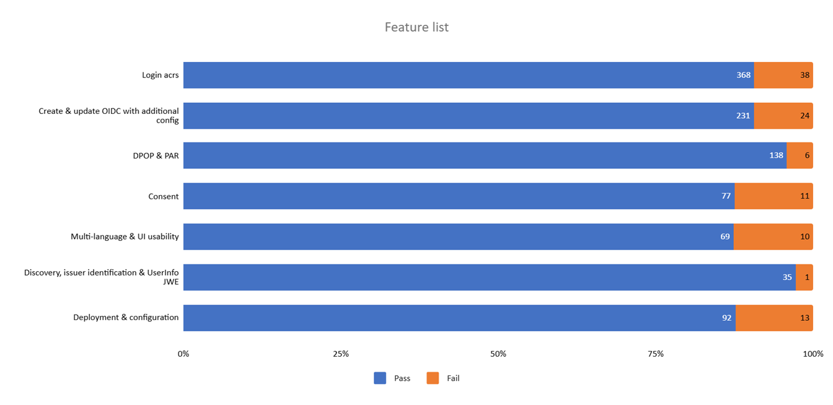
7.1 Known Issues Metrics
This section focuses on a separate category of issues that are known but not addressed in the current release. It provides a count and severity distribution for these defects across releases.
Table 12: Defect Metrics for the known issues
Blocker | Critical | Major | Minor | Total
0 | 1 | 32 | 34 | 67

Sonar Report
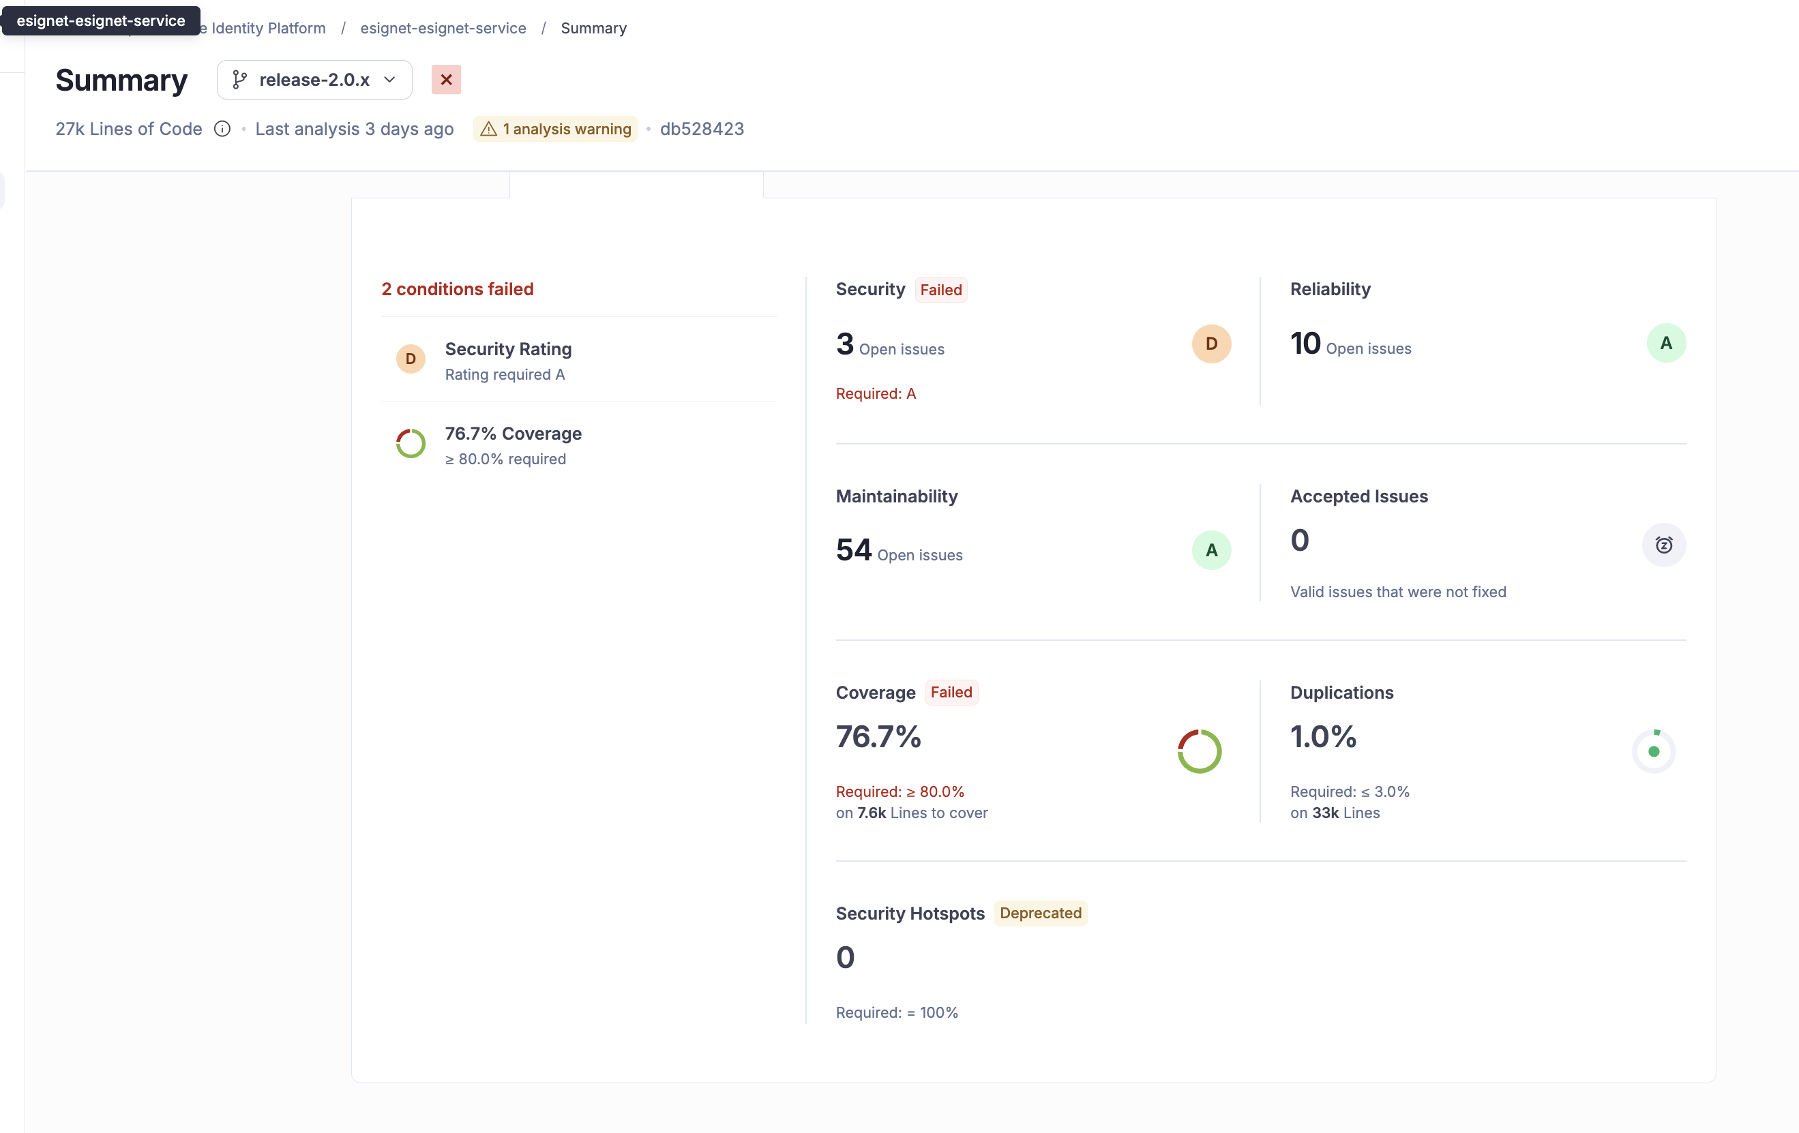

Conclusion
The eSignet 2.0.0 application has been validated in the esqa environment with the Mock ID, MOSIP ID and Sunbird plugins; core functionalities perform as expected and the open issues are tracked as known issues.
Sanity, regression, and integration testing were completed within the defined scope.
- Based on the test execution and results, QA approves the build for the Go release with the known issues listed in the Known Issues Metrics section.
9.1 QA Approval
The build has met the defined exit criteria and is recommended for the Go release based on the following:
- Test Case Execution: All planned test cases (1113) have been executed; 1010 passed and 103 failed.
- Story and Defect Closure: In-scope user stories are verified; 64 open issues (1 Critical, 37 Major, 17 Minor, 9 not set) are tracked as known issues.
- Automation Reports: API-Testrig and UI automation execution reports have been reviewed and approved.
- Documentation Sign-off: All required test and release documentation has been reviewed and signed off.
- Test Environment Stability: The Mock ID and Sunbird environments remained stable.
Table 13 : Report signed off details
Name | Functional Role | Responsibilities
Ragini Krishna | Manager | Defining test strategy, managing QA activities, and ensuring overall product quality.
Prathmesh Jadhav | Lead/ Test Engineer | Leading the test team, planning and executing tests, and ensuring timely delivery of quality results.

Appendix
This includes additional reference information for the report. It contains a history of document versions and a list of acronyms and their meanings.
Version | Date | Author | Reviewers
v1.0 | 22/09/2026 | Santosh | Ragini Krishnamurthy

END OF DOCUMENT

